Name: |  | Writing hand: Left / Right |  | Date:
transferred fingerprint | thumb | index finger | middle finger | ring finger | little finger
 | pattern | pattern | pattern | pattern | pattern
Example: | minutae | minutae | minutae | minutae | minutae
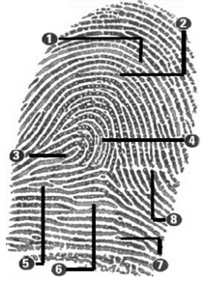

Errors
- What kind of errors can be made in investigating fingerprints?

- Why will fingerprint research always be carried out by two dactylopians?
Conclusions
- How easy is it to recognise fingerprints and link these to a suspect?
Visual | Microscope  (drawing) | Length  (in cm) | Thickness  (in mm) | Other observations | Name hair owner

Conclusions
- What kind of forensic research can be done on hairs?

- How can hairs be linked to a suspect?
Errors
- Look for possible errors and think of improvements.
Nr | Visual | Feel | Light microscope | Water reaction | Other observations | Name textile
1
2
3
4
5
Conclusions
- What kind of forensic research can be done on textile?

- How can textiles be identified?
Errors
- How many textiles did you identify well?

- Look for possible errors and think of improvements.

Nr | Visual | Scent | Stereo  microscope | Water reaction | pH | Other observations | Name powder
1
2
3
4
5
6
7
8

Conclusions
- What kind of forensic research can be done on powders?

- How can powders be identified?
Errors
- Look for possible errors and think of improvements.
Nr | Visual | Feel | Stereo  microscope | Water reaction | pH | Other observations | Soil name
1
2
3
4

Conclusions:
- What are the differences between different soil types?

- How can traces of soil be used as evidence?
Errors
- Look for possible errors and think of improvements.

