H 1. inTRODUCTION
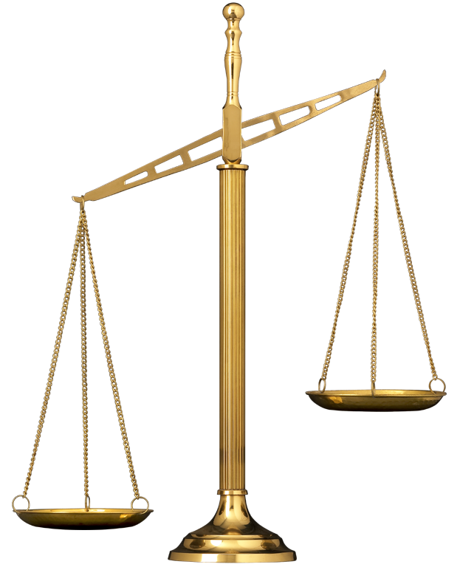
1.1 Background information
Potatoes are eaten by many people in Holland and England. This is pretty recent. The potato was imported from America in the 19th century. Potatoes are important as source of starch and (for fairly new potatoes) vitamin C. But peeling them is pretty laborious. Some people prepare them in their jacket. What would be the use of the jacket?
(An introduction usually is longer, but this will do for now - and you don’t have to write it this first time)

1.2 Research question
What’s the function of the potato jacket? (ready already!)

1.3 Expectation (see ABOUT on p 35)

H 2. Method (ready)
2.1 List of materials
- two potatoes (of about the same size)
- balance
- petri dish, marked
- peeling knife

2.2 Process
- Work in pairs.
- Peel one of the two potatoes (leaving the other one in its jacket)
- Weigh both potatoes separately and write down the date: see table 1.
- Put both potatoes in the petri dish (marked with class and group number) and hand it in.
- Weigh both potatoes again after a week and write down the date: see table 1.
- Write down other things you notice

H 3. ResultS (don’t forget the table titles: see ABOUT on p 37)
Date of weighing > |  |  | difference in percentage
weight (in gs) peeled
weight (in gs) unpeeled
table 1:
Description of the results (with extra things you observed):

group number | 1 | 2 | 3 | 4 | 5 | 6 | 7 | 8 | 9 | 10 | 11 | 12 | 13 | 14 | 15 | 16
start weight peeled (in gs)
end weight peeled (in gs)
difference peeled (in %)
start weight unpeeled (in gs)
end weight unpeeled (in gs)
difference unpeeled (in %)
table 2:

group-number |  |  |  |  | average
difference
in %

table 3: weight loss in percentage of the four HEAVIEST potatoes

group-number |  |  |  |  | average
difference
in %

table 4: weight loss in percentage of the four LIGHTEST potatoes

H 4. EVALUATION
4.1 Conclusions (see ABOUT on p 37)
1: The difference in weight loss between peeled and unpeeled shows that the jacket:

2: The difference in weight loss between large and small potatoes shows that:

3: Other differences between peeled and unpeeled potatoes show that:

4.2 Explanation
1: The difference in weight loss between peeled and unpeeled can be explained as follows:

2: The difference in weight loss between large and small potatoes can be explained as follows:

3: The other differences between peeled and unpeeled potatoes can be explained as follows:

4.3 Errors (see ABOUT on p 37)
